|  |  |  |  |  |  |  |  |  |  |  |  |  |  |  |  |  |  |  |  |  |  |  |  |  |  |  |
| --- | --- | --- | --- | --- | --- | --- | --- | --- | --- | --- | --- | --- | --- | --- | --- | --- | --- | --- | --- | --- | --- | --- | --- | --- | --- | --- |
|  |  |  | **INTERSTATE CONTAINER CORPORATION** | | | ***Date:* 06/14/2016** | ***Spec #:*** | | | | | | | | | | | | ***Design #:* 160492-02_A** | | | | | |  |  |
|  |  |
|  |  |  | ***Customer:*** | **DeMet's Candy** |  |  |  |  |  |  |  |  |  |  |  |  |  |  |  |  |  |  |  |  |  |  |
|  |  |  |  |  |  |  |  |  |  |  |  |  |  |  |  |  |  | ***Cut*** | **184 in.** | | | |  |  |
|  |  |  |  |  |  |  |  |  |  |  |  |  |  |  |  |  |  |  |  |
|  |  |  | ***Description:*** | **WalMart - RSC.462/0 6.4 oz bag - Shipper[Left Handed 1/4"gap]** | | |  |  |  |  |  |  |  |  |  |  |  |  |  |  |  |
|  |  |  |  |  |  |  |  |  |  |  |  |  |  |  |  | ***Crease*** | **134 in.** | | | |  |  |
|  |  |  |  |  |  |  |  |  |  |  |  |  |  |  |  |  |  |
| ***Style:* RSC** | | | |  | ***Revision Info:* [A] 06/10/2016:resized to fit tray revision** | |  |  |  |  |  |  |  |  |  |  |  |  |  |  |  |
|  |  |  |  |  |  |  |  |  |  |  |  |  |  |  |  |  |  |  |  |  |
|  |  |  |  |  |  |  |  |  |  |  |  |  |  |  |  |  |  |  |  |  |
|  |  |  |  |  |  |  |  |  |  |  |  |  |  |  |  |  |  |  |  |  |
| ***I.D. :* 9+5/8 x 9+5/16 x 14+1/2** | | | | | ***Blank size:* 24+1/8 x 39+7/8** |  |  |  |  |  |  |  |  |  |  |  |  |  |  |  |  |  |  |  |  |  |
|  |  |  |  |  |  |  |  |  |  |  |  |  |  |  |  |  |  |  |  |  |
| ***Board:* 32 C K** | | | |  | ***Combination:* 35HP - 23M - 35HP** | ***Designer:* Henry Raymond** | | |  |  |  |  |  |  |  |  |  |  |  |  |  |  |  |  |  |  |
|  |  |  |  |  |  |  |  |  |  |  |  |  |  |  |  |  |  |  |
|  |  |  |  |  |  |  |  |  |  |  |  |  |  |  |  |  |  |  |  |  |  |  |  |  |  |  |
|  |  |  |  |  |  |  |  |  |  |  |  |  |  |  |  |  |  |  |  |  |  |  |  |  |  |  |

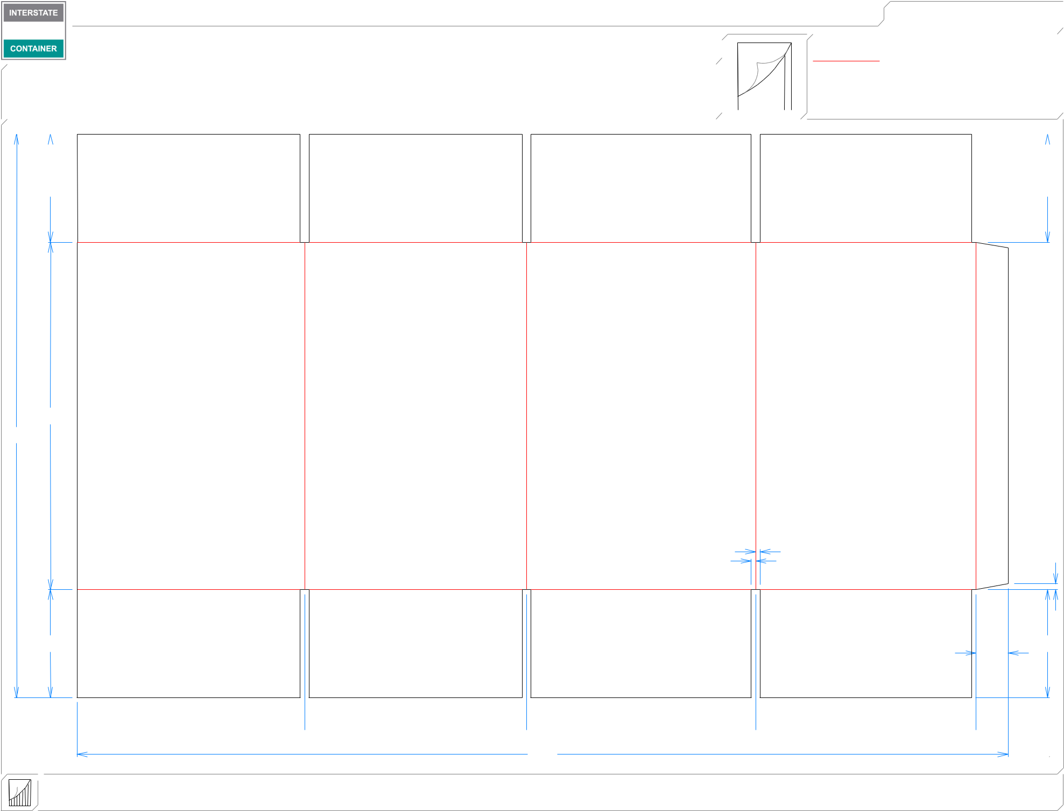

45*/*8 45*/*8

3*/*16  3*/*16

147*/*8

241*/*8

|  |  |
| --- | --- |
| 3*/*16 | 1*/* |
| 3 | 4 |
| */*16 |  |
| 45*/*8 | 45*/*8 |
|  | 13*/*8 |

 93*/*4  91*/*2  913*/*16  97*/*16 

397*/*8

**inside view**

**Vertical Corrugation**

***notes:***

***Qty/unit:*** ***Area - waste:* 6.51 sq. ft** ***Waste on blank:* 2.6%** ***Piece weight - waste:* 0.68 lbs./309.42 g**